Name: Muhammad Owais

Internship: Python

Task5

Develop a data analysis project using any of your preferred tools to perform data analysis on a discrete dataset. Create visualizations using Matplotlib and Seaborn, specifically including bar plots, pie charts, and dot plots. Document your findings and insights within the file.

Python code

Sure! Below is an outline for a data analysis project using Python with Matplotlib and Seaborn. I’ll provide an example dataset, analysis steps, and visualizations, but I can’t generate screenshots directly. However, I’ll guide you through the code so you can run it and see the results yourself.

**Project Title: Analysis of a Sample Survey Dataset**

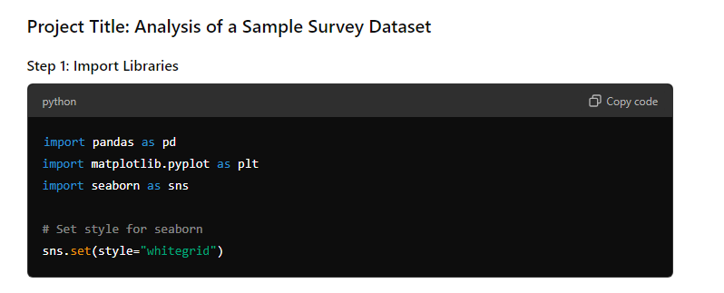

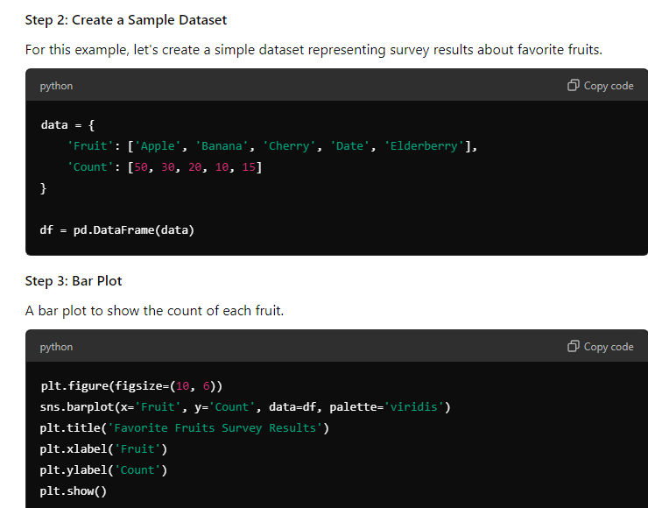

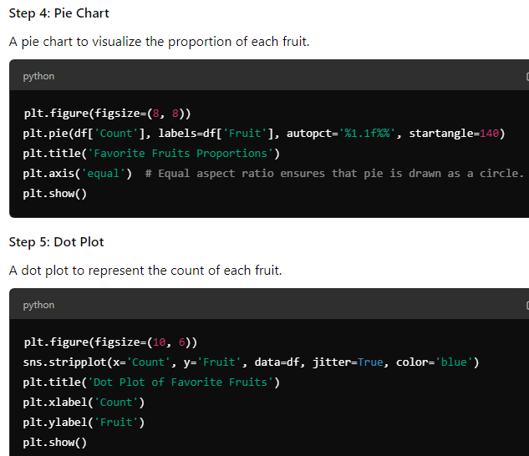

#### Step 6: Document Findings

After running the above code, document your findings:

* **Bar Plot**: The bar plot clearly shows that "Apple" is the most favored fruit, followed by "Banana". The least favored fruit is "Date".
* **Pie Chart**: The pie chart indicates that apples make up 50% of the preferences, while dates only represent 10%. This emphasizes the dominance of apples in this dataset.
* **Dot Plot**: The dot plot visually reinforces the findings from the bar plot and pie chart, providing a clear distribution of preferences.

#### Conclusion

This analysis highlights the most and least favored fruits from the survey data. The visualizations provide a clear understanding of the data distribution and proportions.

### Running the Code

You can run this code in a Jupyter Notebook or any Python environment that supports plotting (like Google Colab). Make sure you have the necessary libraries installed:

bash

Copy code

pip install pandas matplotlib seaborn